Big Query – Homework #4

SQL queries

CREATE OR REPLACE TABLE ny_green_taxi_data.green_taxi_data_2022 AS

SELECT * FROM big-query-demo-414116.ny_green_taxi_data.external_green_taxi_data_2022

Question 1

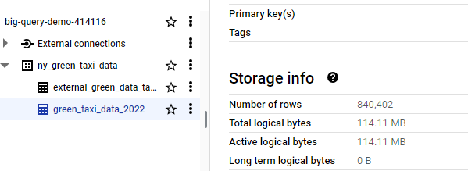

Question 2

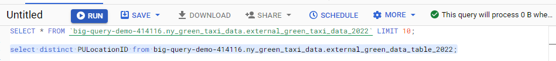



Question 3

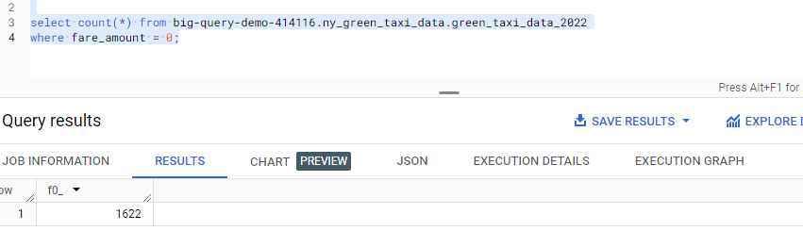

Question 4

Create or replace table ny_green_taxi_data.green_taxi_data_2022_partitioned_clustered

PARTITION BY DATE(LPEP_PICKUP_DATETIME)

CLUSTER BY VendorID AS

SELECT * FROM big-query-demo-414116.ny_green_taxi_data.green_taxi_data_2022;

Question 5

select distinct PULocationID from big-query-demo-414116.ny_green_taxi_data.green_taxi_data_2022

where DATE(lpep_pickup_datetime) between '2022-06-01' and '2022-06-30'



select distinct PULocationID from big-query-demo-414116.ny_green_taxi_data.green_taxi_data_2022_partitioned_clustered

where DATE(lpep_pickup_datetime) between '2022-06-01' and '2022-06-30';



Question 6

Where is the data stored in the External Table you created?

Ans : GCP bucket

Question 7

It is best practice in Big Query to always cluster your data:

Ans: False

Question 8:

Write a SELECT count(*) query FROM the materialized table you created. How many bytes does it estimate will be read? Why?

select count(*) from big-query-demo-414116.ny_green_taxi_data.green_taxi_data_2022;

It show 0 bytes as the query will return the results based on the metadata rather than do a scan of the entire table.